ERYA Profiling

User Guide & Tutorial

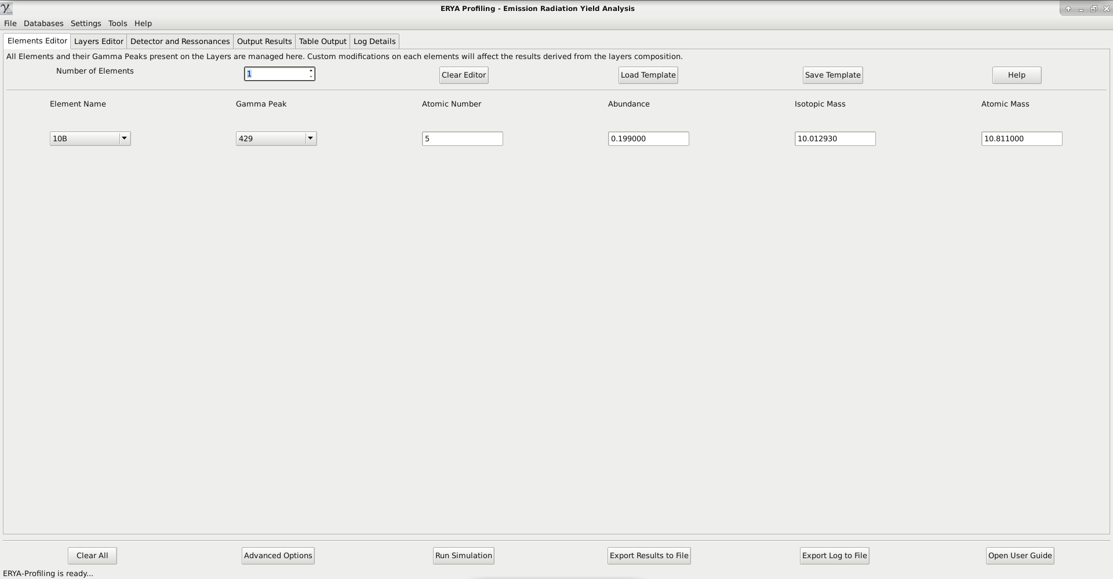

**Contents**

**Introducing ERYA Profiling:**

*Welcome!*

*Physical Theory of Gamma Ray Emission Yield Analysis*

*What’s New on ERYA Profiling?*

*Quick Start!*

*Changing Setup Settings*

*Setup Troubleshooting Guide*

**Explore the Database Management Tools:**

*Detector Efficiency*

*Ziegler Parameters*

*Element Database*

**Master the Program Tools Utilities**

*How to Import Databases from previous LabView ERYA programs (Legacy)*

*Using the ERYA Calculator*

*How to Import SRIM tables to Ziegler’s Parameters (Optional)*

**How to Make a Profiling Analysis:**

*How to define your Sample*

*Advanced Accuracy Parameters (Optional)*

*How to import Experimental Data*

*Useful Tips*

*A Profiling Example*

**Bibliography:**

**Introducing ERYA Profiling**

**Welcome!**

ERYA Profiling is a software application designed to aid the analysis of heterogenous samples, where the main task is determine their composition in terms do their elements and/or isotopes quantities.

It is the natural evolution of the ERYA-Bulk program, where the main difference is that a more realistic physical model are applied.

The efficiency of the method implemented by this software depends highly of the physical model, experimental setup and measurement accuracy.

In general, the measurement of samples beamed by light particles are more precise when the sample had lighter elements than weighted ones, and this fact make possible to use the excitation function of lighter elements by their gamma emissions to determine the composition of the sample.

PIGE refers to Particle (mainly protons) Induced Gamma-ray Emission, resulting from nuclear reactions between the sample and the impinging particles. As the cross sections related to these reactions, at proton energies in the range 2- 5 MeV, favor nuclear reactions in the lighter isotopes, PIGE deals mainly with light element analysis.

The ERYA code calculates the elemental concentrations from ab-initio principles, surpassing the need of a comparative method based on standards, and achieving quick and easily the pretended results.

The performance of PIGE analysis based on this software depends on the physical model, experimental setup and measurement accuracy.

ERYA-Profiling was developed at LibPhys-UNL,by the institution *Faculdade de Ciências e Tecnologia* (FCT) - *Universidade Nova de Lisboa* (UNL), on *Departamento de Física* (Physics Department), postal code address 2829-516 Caparica, Monte da Caparica, Portugal.

ERYA-Profiling was programmed by Vasco Manteigas ([vm.manteigas @ campus.fct.unl.pt](mailto:vm.manteigas@campus.fct.unl.pt)), with advice from Micaela Fonseca (micaelafonseca @ fct.unl.pt), and Luís de Souto Martins, where first one was the original programmer of the previous LabView ERYA version, and the second one implements the numerical routines of the first version of ERYA-Profiling, bundled on LabView version.

**Physical Theory of Gamma Ray Emission Yield Analysis on Heterogeneous Samples**

The program evaluate the stoichiometry composition of an heterogeneous sample, make by several layers, where each one composition can be made of several elements, by evaluate the nuclear reaction yield of each element. Since, in theory, the yields depends of their relative stoichiometry, it is possible to find the correct sample composition using this method.

On the homogeneous case, each individual yield could be evaluated from the following integral:

$Y\left(E_{0}\right)=ϵ_{\text{abs}}\left(E_{γ}\right)n_{p}f_{m}f_{i}N_{A}A^{−1}\int_{0}^{E_{0}}{\frac{σ\left(E\right)}{ϵ\left(E\right)}}dE$ (1)

Where it depends from the Detector Efficiency (εabs) at the element gamma ray emission energy, the number of protons (np), the element/isotope relative abundance (fi), the relative fraction mass (fm), the isotope/element atomic mass (A) and Avogadro's Number (NA).

Both multiplied by the proper integral in function of energy, where depends from the element’s cross-section excitation function (σ) and the stopping power (ε). Each of relevant functions depends from the relative stoichiometry of the sample.

When the sample are heterogeneous, the integral is a little more complicated, since the the terms related to the relative stoichiometry now depends on the depth, or energy, where it turns to be:

$Y\left(E_{0}\right)=ϵ_{\text{abs}}\left(E_{γ}\right)n_{p}N_{A}A^{−1}\int_{0}^{E_{0}}{\frac{f_{m}\left(E\right)f_{i}\left(E\right)σ\left(E\right)}{ϵ\left(E\right)}}dE$ (2)

And a more realistic model of energy dissipation require to take account of the energy loss of the beam. This require to model a distribution of the energy straggling dissipation, and another distribution related to the own detector’s physics, where on on-line help is called, by convenience, the thermal distribution.

Since the energy variable can be spitted by the sum:

$E=\overline{E}−ΔE$ (3)

Making a distinction of the average energy $\overline{E}$, and energy dispersion $ΔE$, the integral in (2), can now be written:

$Y\left(E_{0}\right)=ϵ_{\text{abs}}\left(E_{γ}\right)n_{p}N_{A}A^{−1}\int_{0}^{E_{0}}{\int_{−∞}^{∞}{\frac{f_{m}\left(E\right)f_{i}\left(E\right)F\left(\overline{E}\right)σ\left(\overline{E}\right)}{ϵ\left(E\right)}}}dE\overline{dE}$ (4)

Where the cross-section on ERYA-Profiling is now an integrable function along the dispersion distribution F. And since the actual distribution is the convolution of a thermal and a straggling one, the integral (4) is now a triple integral:

$Y\left(E_{0}\right)=ϵ_{\text{abs}}\left(E_{γ}\right)n_{p}N_{A}A^{−1}\int_{0}^{E_{0}}{\int_{−∞}^{∞}{\int_{−∞}^{∞}{\frac{f_{m}\left(E\right)f_{i}\left(E\right)F_{T}\left(\overline{E}'\right)F_{S}\left(\overline{E}−\overline{E}'\right)σ\left(\overline{E}\right)}{ϵ\left(E\right)}}}}dE\overline{dE}\overline{dE}'$ (5)

In order to simplify (5) to be reasonable to implement the numerical integration of the yields, the program make the following simplifications:

- The sample are sliced by several layers with a constant depth in terms of 1015 at/cm2*,* where the stoichiometry can be constant of each element, then the yield of an element is the sum of all partial yields respective to each layer, this replace the energy integration, by a sum of partial yields:

$Y\left(E_{0}\right)=\sum_{L=1}^{N}{Y_{L}}\left(\overline{E_{L}}\right)$ (6)

And the average energy at the current layer $\overline{E_{L}}$ is constant, leaving the integral of the distributions separated, since:

$Y_{L}\left(E_{L}\right)=ϵ_{\text{abs}}\left(E_{γ}\right)n_{p}f_{m}\left(\overline{E_{L}}\right)f_{i}\left(\overline{E_{L}}\right)N_{A}A^{−1}\int_{x_{0}}^{x_{1}}{\int_{y_{0}}^{y_{1}}{\frac{F_{T}\left(x\right)F_{S}\left(y−x\right)σ\left(\overline{E_{L}}−y\right)\overline{ΔE_{L}}}{ϵ\left(\overline{E_{L}}\right)}}}dxdy$ (7)

Where the double integral domain $x=\left[−3Ω_{T},3Ω_{T}\right];y=\left[λ_{0,}λ_{0.995}\right]$ are truncated along the 3-sigma approximation of the relevant distributions.

The thermal distribution is a Gaussian Distribution, truncated at 3-sigma, where it is numerically trivial to evaluate. The straggling is modeled by a Vavilov Distribution or Gaussian Distribution, depending from the user choices.

A full discussion of the numerical Vavilov Distribution is out of scope of this manual, but some additional information can be retrieved on on-line help, and a full description are elucidated on the program bibliography.

ERYA profiling evaluate the yields integral by calculating the integral (7) for each step on (6), where the average energy are evaluated by an energy loss step defined by:

$\overline{ΔE_{L}}=n_{L}ϵ\left(\overline{E_{L+1}}−\overline{E_{L}}\right)$ (8)

Where the first layer had the initial incident energy $E_{0}$, and $n_{L}$ are atomic density of the current layer.

**What’s New on ERYA Profiling?**

This application was a full rewrite of a previous LabView program that handles the PIGE database management, and an additional program that made the numerical profiling of the sample. Actually such program was only a prototype and never released outside of CTN.

ERYA Profiling is now fully implemented on C++ language, while the core framework, including the Graphic User Interface, are derived from a cross-platform library called wxWidgets.

wxWidgets is an open-source framework inspired from the Microsoft Foundation Classes, and compliant with the Standard Template Library, while extends to be compatible to several operating systems and computer architectures, easing the port to several systems.

The new ERYA Profiling (Emitted Radiation Yield Analysis) are available natively for Windows, Linux and Mac OS X, and several modern computer architectures, since it runs on 32-bit and 64-bit Intel/AMD x86 processors.

Windows versions requires Windows 7 or later. Previous Windows versions could run, but such configuration is not supported.

Mac OS X are only available on 64-bit x86-64 Intel architecture, and requires version 10.11 or greater to work. It could run on older versions, since ERYA will not check the Mac OS X version, but expect potential issues on older systems.

All Linux packages are designed to work with any Debian derived Distribution, as long contains the wxWidgets 3.0.4 libraries updated, and require at least Debian 9 Stretch with backports repositories enabled, or Ubuntu 18.04 LTS versions to work.

A special build for Linux computers with ARM processors are also available, including the Raspberry Pi 3 Plus board. The supported Linux operating system requirements are the same of the Intel/AMD ones.

ERYA bundles a Database with over 100 elements and isotopes, the 1977 and 1991 Ziegler Parameters, the 2013 SRIM Stopping Power tables, and some sample Detector profiles. Both of all those files can be edited by the user, using the tools provided by this software that will be described on next chapters on this tutorial.

**Note:** If you are a former user of the LabView ERYA, you will notice the familiarity of several options on this new software, along the new improvements. ERYA can also import the old databases and convert them, requiring a brief reading of the legacy features chapter of this manual.

**Notice:** If you are interested to contribute to maintain the wxWidgets ERYA Profiling source-code, or any issue related to the program use, please contact the programmer by it’s e-mail.

The new ERYA-Profiling Main Program User Interface...

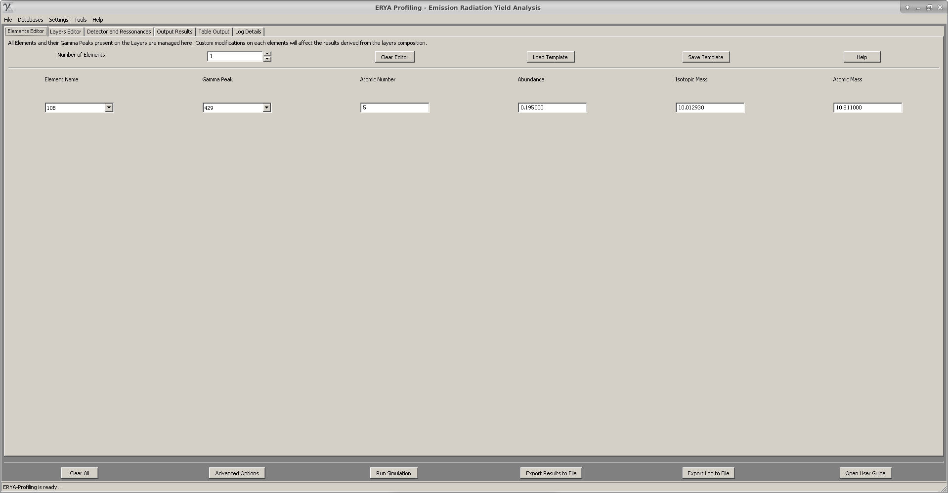

At a technical level, the major features are:

1. A new unified Database format for the Elements, the Detector Efficiency and the Ziegler Parameters, which uses the standard XML document format, given flexible data storage, an hierarchical data content structure, and a more standardized method to read and write the contents.

2. An on-line help, based on HTML pages, and directly accessed by the program, which explains the main program features, and major tasks.

3. New file filter imports for IBANDL files, SRIM files, generic spreadsheet-like ASCII source files and Excel 2007 Xlsx files, in order minimize the steps needed to convert the original data to the native ERYA database structures.

4. The whole GUI was written from scratch, and uses the new wxWidgets objects which facilitates the handling of events, and implement a more concise work-flow. And also simplifies the porting to several operating systems.

**Quick Start!**

The installation of ERYA on any supported operating system is straightforward.

- Select the adequate package which matches your operating system and architecture, and download it to your computer. As a rule of thumb, Linux versions should have the *amd64, i386, arm64, armhf* suffixes (first half are for Intel, and later half are for ARM machines.). Windows versions are identified with *win64* or *win32* versions. Mac OS X version are identified by *osx* suffix.

**Windows:** All Windows packages contains the wxWidgets libraries and GNU C++ Runtime Library inside the executable package. The installation wizard program will install ERYA to the default Program Files folder, and will create a Start Menu entry.

**Linux:** Linux versions of ERYA are available on Debian package format (deb), and any Linux distribution compatible with Ubuntu 18.04 LTS or Debian 9 Stretch will install automatically.

► It is highly recommendable to use the apt/dpkg package manager from Terminal to minimize potential installation errors, even on Ubuntu that had GUI tools to install packages:

$ **sudo apt update** (Refresh the repositories)

$ **sudo apt dist-upgrade** (Update manually your system)

$ **sudo dpkg -i *.deb** (Install the package)

$ **sudo apt -f install** (Install the missing libraries from your Linux repository.)

► Debian distributions had more tight security features, and require to open a root shell from Terminal:

$ **su** (And type your root password)

# **apt update** (Refresh the repositories)

# **apt dist-upgrade** (Update manually your system)

# **dpkg -i *.deb** (Install the package)

# **apt -t stretch-backports -f install** (When using Debian 9 Stretch)

**Warning:** ERYA was not tested on Linux distributions tailored to perpetual beta staging, like Arch Linux or their derivatives.

**Mac OS X:** For Apple Macintosh users, once downloaded the Mac OS X package and unzip it, it just need to copy the ERYA-Profiling.app package to the Applications folder.

Finally, click on ERYA-Profiling icon to run the software on Mac OS X.

**Starting ERYA-Profiling:**

- On Windows, select Start > ERYA-Profiling, and ERYA-Profiling main icon.

(On Windows 10, type ERYA on search-box to grad the launcher quicker)

- On Linux, select the icon from Programs > Education/Science > ERYA-Profiling.

(The real category can vary according to the default’s Desktop Manager of your Linux distribution.)

- On Mac OS X, open the Applications folder from Finder, and then find and click on ERYA-Profiling icon to start the program.

**Removing ERYA-Profiling:**

- On Windows, select the uninstaller icon, or from “Control Panel”>”Program and Features”, select the ERYA-Profiling group, and follow the instructions.

Open a Command prompt to delete the user profile folder:

$ **rmdir -s** **C:\users\name\Local Settings\Application Data\ERYA-Profiling-Win64\**

$ **rmdir -s** **C:\users\name\Local Settings\Application Data\ERYA-Profiling-Win32\**

- On Linux, open a terminal application and type the following command as root:

**$ sudo apt-get remove eryaprofiling**

$ **rm -rf ~/.ERYA-Profiling**

- On Mac OS X, simply delete the “ERYA-Profiling” program from “Applications” folder on Finder.

Open the Terminal.app to delete the user profile directory:

$ **rm –rf ~/Library/Application Support/ERYA-Profiling-OSX/**

- Consult the table on next “Initial Setup” section, to find and delete the local profile folder, before adapt the commands described above.

**Note:** Read the Setup and Troubleshooting sections for solution to the most common issues, before contact ERYA’s author for help.

**Initial Setup**

Once ERYA-Profiling is successfully installed, will need a configuration file in order to work properly.

When ERYA-Profiling starts for the first time, the program will starts a wizard to guide the user to configure the software properly.

The wizard will ask the user to select from the bundled database files, which ones will be the Element Database, Detector Efficiency and Ziegler Parameters databases. While it is possible to skip the wizard, it is not recommendable to use ERYA without any loaded databases.

Once selected all necessary files, the wizard will ask to the user select a local or portable profile.

The key differences are displayed on this table:

|  |  |  |  |
| --- | --- | --- | --- |
| **Operating System** | **Windows** | **Linux** | **Mac OS X** |
| **Portable Setting** | **In the same program directory** | | |
| **Local User Profile** | **C:\users\name\Local Settings\Application Data\ERYA-Profiling-Win64\\*** | **/home/name/.ERYA-Bulk/\*** | **/Users/name/Library/ Application Support/ERYA-Profiling-OSX/\*** |
| **Config Name** | **ERYA-Profiling-Win64.conf** | **ERYA-Bulk.conf** | **ERYA-Profiling-OSX.conf** |

**Portable Setting:** Once the configuration file are written on the root program directory, the setup is complete. Any changes on default Detector, Elements and Ziegler will overwritten the original program ones, since you set the same working directory.

**Local User Profile Setting:** This is recommendable configuration, since the wizard will store a copy of the default Database, Ziegler and Detector files on the directory defined on previous table.

Since the user change the local copies of databases, it leave the original program ones, that could be used as an informal backup that make possible a program reset in case of a serious error.

**In the End:** Once all wizard steps are done, the configuration file are created and tested. If ERYA don’t find any problems during the Databases loading phase, the main GUI interface will appear.

**Warning:** If ERYA delivers an error message about invalid or corrupted databases, please read the Troubleshooting chapter of this manual.

**Running ERYA for the First Time**

**1.** When ERYA-Profiling runs for the first time, it will warn that don’t found any configuration files, triggering the Setup Wizard. In case of a previous ERYA-Profiling installation, the program will load the old configuration file, and the associated databases. To avoid this, read the *Initial Setup* section to delete manually any previous configuration file, and start this guide over again.

**2.** If no previous configuration file exists, ERYA will start a wizard, guiding the user for the next steps.

**3.** ERYA’s wizard will ask the user to select the start-up Element Database from the ERYA’s package. Normally the file opening dialog will point to the program directory, and here the user should select the file with an **epd** extension.

**4.** The same logic will apply for the Detector Profile file, what had an **epsd** extension.

**5.** Finally, choose the file for the Ziegler Parameters, what had an **epsz** extension. ERYA’s package contains at least three versions (Including the converted SRIM tables, that is the recommend one), leaving to the user choose one of them.

**6.** At the last wizard page, the user can select the profile setting:

- Local (default) folder profile;

- The program root folder profile.

It is highly recommendable to select the local profile setting, since modern operating systems creates separate configuration folders for each user, preventing normal users to write data on program’s directory.

**7.** Once the user finishes the wizard, it will create the necessary configuration files on the target directory, taking only a few seconds to complete.

**8.** ERYA-Profiling is now ready to use, once the selected databases on the wizard loads without errors, and the program GUI appears on screen.

► On next start-ups, the program will load the configuration file automatically, and the main GUI starts without additional user input.

**Warning:** In case of any errors related to the databases or configuration files, read the *Troubleshooting* guide to resolve them.

**Changing Setup Settings**

When needed, the user can change any start-up databases at any time, and ERYA provides a tool accessible from Database > Setup Default Databases… menu.

The actual configuration will be displayed on the different widget controls:

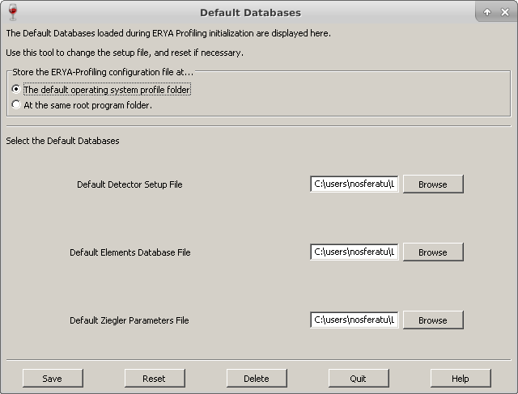

► Once changed the parameters, select the following buttons to:

“Save” will create a new configuration file directly.

“Reset” will clear the widget contents, without affect the actual configuration.

“Delete” will delete all configurations, and force to start a new Setup Wizard.

“Quit” will close the widget leaving the actual configuration untouched.

**Tip:** To erase all damaged configuration files, and local copies of ERYA’s databases, select *Delete* button. This will make the same process of a manual deletion of the local profile folder described on *Quick Start* chapter.

**Setup Troubleshooting Guide**

► This chapter is a quick guide to fix some common problems that can occur with the utilization of this software.

**1. ERYA warns with a message like “Invalid Database”, where one or all databases are absent or cannot be loaded at all.**

**►**At top menu, select Database > Setup Default Databases, and select the correct files.

- If the problem persists, select “Delete” to delete all local data, and start a new Setup Wizard (All custom changes will be lost!)

**-** Alternatively, delete the configuration files and profile folders manually.

**-** Avoid to use third-source database files to perform a clean installation, since it could be the source of problems.

**2.**  **ERYA cannot write any file, even the configuration file, on certain folders.**

► This problem occurs when ERYA is trying to write on a protected folder that requires additional privileges. To solve this problem, select other folder that don’t require special permissions.

**-** Warning: ERYA-Bulk’s author recommends that in any circumstance, **you should not run** ERYA-Bulk with administrator privileges, in order to improve stability and security!

**3. ERYA’s dialog sizes are too small/big.**

**- Label’s font size on dialog are too tiny or cropped.**

**- The whole interface don’t fit to the computer screen.**

**►** ERYA GUI’s code relies on the automatic window sizing delivered by wxWidgets framework, but in some cases, issues are inevitable. To correct this problem, check the following:

- Select the default operating system's DPI (around 72 or 90 dots per inch) to avoid abnormal font sizes on dialog labels.

- ERYA’s optimal screen size are between 1280*720 and 1920*1080. Avoid screen resolutions below 800*600, since it will not display many dialog controls correctly.

- ERYA’s main window will allocate scroll bars for smaller screens.

- If necessary, use the mouse to grab and change the dialogs windows sizes manually.

► Until the current date of publication, manual resizing of dialog windows may be needed when ERYA runs on computers with 4K (3840*2160) monitors, or higher.

Explore the Database Management Tools

**Detector Efficiency**

One of key features of ERYA is the possibility to model the Detector’s Efficiency for gamma radiation in function of energy.

The Detector Efficiency control panel should open from Databases>Detector Efficiency menu:

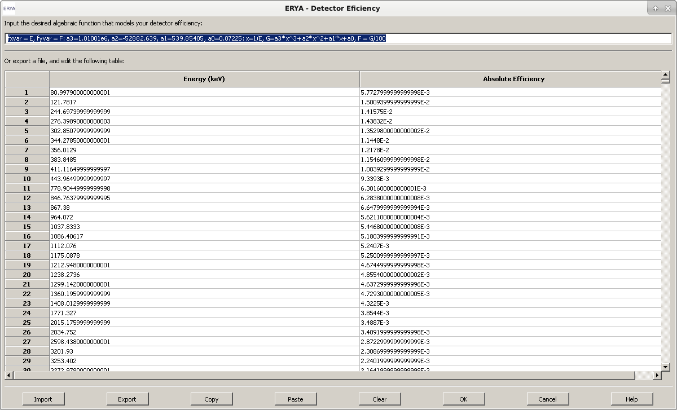

In practice, this editor combines a text field, intended to the user code an algebraic function, that should give the Detector Efficiency in function of Energy, and a two-column table to fill any experimental values that serve for the same purpose.

The origin of this dual configuration is mainly for compatibility with old programs, or with detectors which efficiency was determined experimentally.

Both fields can be filled simultaneously on the built-in editor, and stored on the profile file. However ERYA will choose the function field by default if it is correctly defined, ignoring the table contents.

When the efficiency are exclusively defined by experimental values, it is advisable to fill the highest number of experimental points possible, not forgetting to take attention to the energy gaps between two consecutive values.

**Managing the Detector Efficiency profile file**

While it’s possible to use the built-in spreadsheet editor to fill efficiency data, the user can also export any compatible experimental values from external files.

The native Detector Efficiency profile file format is a XML file, that stores the experimental efficiency points, and the additional user defined efficiency function. This file had a **epsd** extension.

By other hand, it is possible to export and import the experimental efficiency (the custom function are discarded) from or to an ASCII file, which requires to be a full numerical two columns of data, separated by a space or tab. Excel files are also supported by similar way.

The Excel file should be a simple sheet (or fill the first sheet only) with only two columns of numbers, and it is fine to add labels on the first row, which will be ignored. Any graphics or special attachments to Excel file will also be ignored.

The ERYA’s Excel file filter only supports Excel 2007 and beyond version files (with **xlsx** extension), and only recognizes cells with names and numbers.

It is also possible to copy the table contents to a text or spreadsheet file, but this feature is very error prone. In order to copy the table, select the contents from the editor, and click “Copy”, then paste to your text editor. The reverse is similar, once copied from the source, it requires to click on the first target cell, and then click “Paste”. If necessary, clear the built-in table by clicking “Clear”.

Any edition can be stored by using the “Export” button, and then choose the native XML (epsd), ASCII (txt) and Excel (xlsx). You should overwrite the start-up Detector Profile, as you defined on initial setup and described on “Quick Setup” chapter, to make permanent changes.

Stored and additional Detector profiles can be loaded from the “Import” button, and it will overwrite the previous content on the editor.

To override at the current session the loaded Detector’s Efficiency, change the values and then click “OK”. When closes ERYA, the changed values are lost, since the profile file was nor changed.

Hitting the “Cancel” cancel, any edition will be discarded.

**Custom Efficiency Function**

The optional algebraic efficiency function are implemented on ERYA as a input line box to the user code a custom function, overriding the table interpolation.

In technical terms, is a trimmed-down macro language designed to code custom functions without needing to recompile the application for different kinds of functions. A more detailed documentation are included on program’s on-line help.

Taking the following example, as a good starting point:

**fxvar = E, fyvar = F: a3=-2078.4, a2=-312.84, a1=5.006, a0=0.001:**

**x=1/E, F=a3*x^3+a2*x^2+a1*x+a0**

It represents symbolically the following function:

$ϵ_{\text{abs}}\left(E_{γ}\right)=0.001+5.006E_{γ}^{−1}−312.84E_{γ}^{−2}−2078.4E_{γ}^{−3}$

A ERYA macro are single line programs, where each command are algebraic functions separated by colons (:). By convention, a full featured ERYA macro begins with a declaration section for the essential function variables, and ends with the function itself at the last section.

The first field should be used to define the function variables names (It can be any sequence of letters and numbers, as long the first character is a letter), as long don’t override the reserved words.

The special commands **fxvar** and **fyvar** followed by the assignment sign (=) and the variable name, is used to define the independent and dependent function variable, respectively. All sequences should be separated by commas (,), in order to the interpreter chain the variables to the stacks.

Any major field are separated by a colon (:) operator, where the interpreter store the assigned variables values to the respective memory stacks.

An optional middle field can be used to define numerical constants, placing any valid variable name, followed by an assignment sign (=) and a numerical value, or any numerical or algebraic expression that can depends from previous variables values defined earlier.

The rightmost field are reserved for the algebraic function itself, and should contain all function variables defined on previous sections.

To simplify the function declaration, it is possible to make a chain of functions separated by commas (,), as long all relevant variables and partial functions are previously declared.

Like the own example already shown, by defining a compound function by the variable *x* as x=1/E, the main function can be written as a normal polynomial.

In case of use any undefined constant on any expression, will trigger an undefined variable declaration error when ERYA starts a numerical simulation. A syntax check is also triggered when the user click on “OK” button, and if an error are detected the panel is not closed, and an error message are displayed instead.

**Stopping-Power Database**

Like the Detector counterpart, the Stopping-Power widget follows the same layout and functions, albeit exists some key differences. ERYA-Bulk inherits the original Ziegler’s Parameters model from the previous LabView ERYA software.

In order to expand from the old software limitations, ERYA supports custom algebraic functions, and the SRIM tables.

The Stopping-Power Editor are opened from Databases > Stopping-Power:

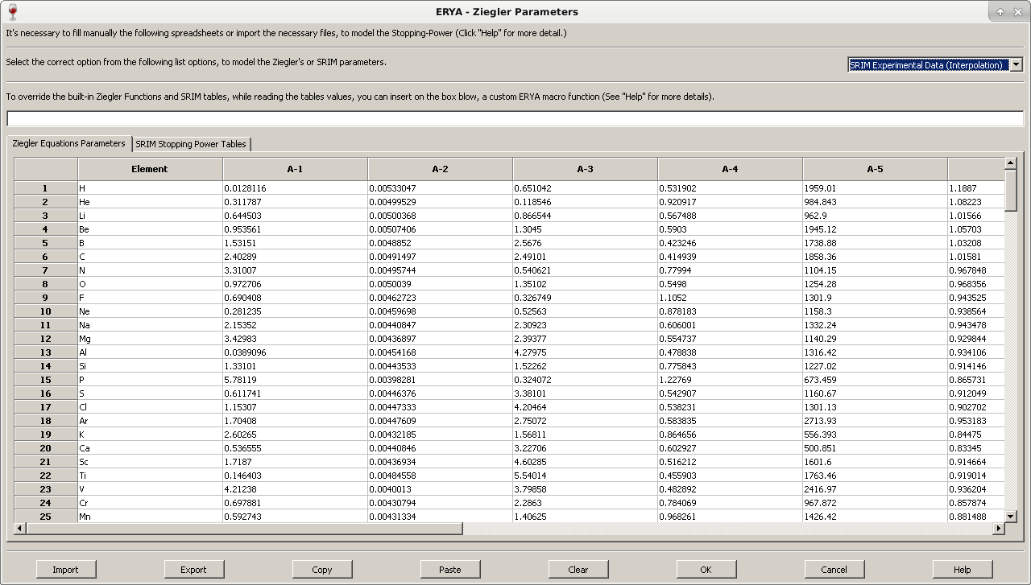

The Ziegler’s Parameters profile file stores not only the Ziegler’s Parameters derived from 1977 and 1991 models, but also the converted SRIM tables for all elements, and a custom ERYA macro.

The data is stored in a XML file with **epsz** extension and contains all data editable by this panel.

The top pull-down menu selects the stopping-power model applicable to all numerical simulations. The first ones corresponds to the Ziegler’s model (either the 1977 or 1991 equations, hard-coded on program.), that requires to fill the “Ziegler” tab with the parameters on the built-in spreadsheet as displayed on the figure. This corresponds to the original LabView ERYA stopping-power model.

The algebraic and SRIM modes are explained with more detail on next sections.

**Cautions between ERYA-Bulk and ERYA-Profiling Ziegler’s Parameters**

Both programs use the same XML based document with *epsz* file extension, but had a slight difference: the ERYA-Profiling had two additional columns for the density and mean ionization constants.

►This means, that if ERYA-Bulk reads the ERYA-Profiling Ziegler’s database it will discard the two unused columns (and save it will rebuild as the expected ERYA-Bulk version).

►And ERYA-Profiling when read the ERYA-Bulk version will add a filler value “1” to all densities, and “10” for all mean ionization parameters, if the user accept the warning dialog.

- For other formats (Excel and ASCII), ERYA-Profiling will process the files by the following rules:

►ERYA-Profiling will load all ASCII, XML and Excel files created by ERYA-Bulk, but will warn that the absence of the density and mean ionization columns, asking to continue the import, or abort at all. If the ASCII or Excel files corresponds to a interpolated table with two columns (derived from SRIM), there’s no ambiguity.

►When the user saves a Ziegler’s Parameters to ASCII and Excel files, it always save the density and mean ionization columns. Those files will fail to open on ERYA-Bulk.

**Using the Custom Ziegler’s Functions**

Using the Ziegler’s version modes pull-down menu, it is possible to activate the custom algebraic function, as long exists a macro program on the respective input-box. When selected, once the user try to validate with the “OK” button, ERYA will trigger the same syntax check of Detector’s efficiency widget, and will display the first error found during the tests.

The overall syntax rules on Ziegler’s Parameters are equal to the ones on Detector’s efficiency, and the only real difference is a third obligatory command called **fnvar** that create a sequence of 16 variables, instead of one. The first variable had the same name as defined by the assignment sign (=). The other 15 variables are simply the same name base, appended with a number from 1 to 15.

This means that if the user defines a *zn* variable as **fnvar**, as displayed here:

**fxvar = x, fyvar = y, fnvar = zn : …**

Then the following variables are created on the interpreter’s memory stack: *zn, zn1, zn2, …, zn15*.

All 16 variables created by the **fnvar** command will be used by ERYA to copy the entire line of the Ziegler’s Parameters spreadsheet automatically to those variables:

► The first base variable will be the Element’s Atomic number;

► The next 12 variables will be the A-1 to A-12 parameters;

► The variable with *13* suffix will be the Atomic Mass.

► The variable with *14* suffix will be the Atomic Density.

► The variable with *15* suffix will be the Bloch Parameter.

**Note:** On most common uses, the Custom Stopping-Power Function are used mainly on tests, where it may be useful to code a constant stopping-power to certain samples.

For example, to define a constant stopping-power of 1.77*1015 at/cm2, just write the following code:

**fxvar = x, fyvar = y, fnvar = zn : y = 1.77**

Or alternatively, write with a symbolic constant on function:

**fxvar = x, fyvar = y, fnvar = zn : c = 1.77 : y = c**

**Using the SRIM Stopping-Power Tables**

To manage the converted SRIM tables, select the pull-down menu to “SRIM”, and select the “SRIM” tab to edit the chain of spreadsheets in a fashion similar to the Detector’s Efficiency.

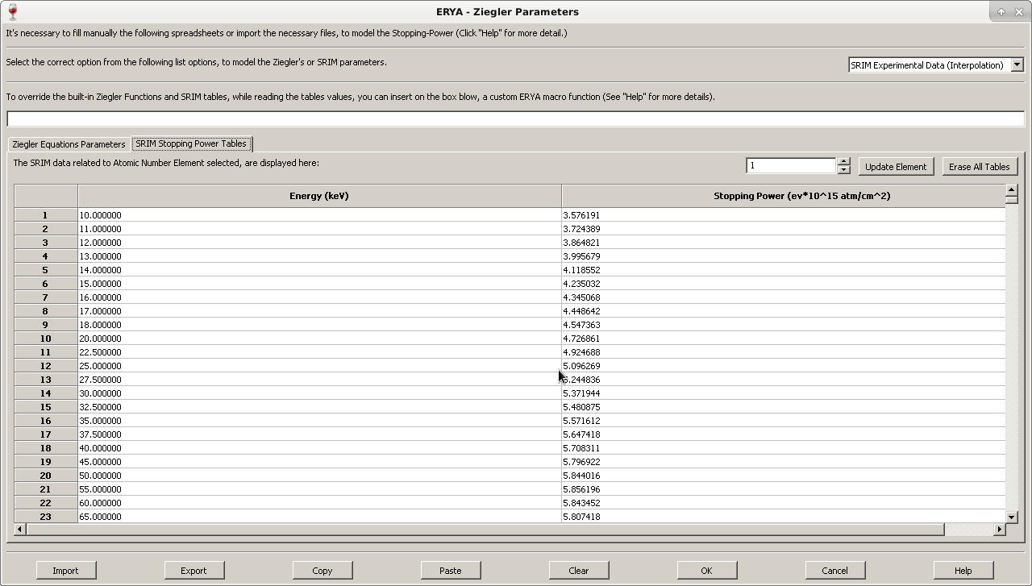

The only main difference on SRIM tables from Detector’s widget is the SRIM’s Spreadsheet editor can only display an element each time, even several elements reside on memory, or the original file. In order to display other tables, just change the numerical value on the switch-box that corresponds to the Element’s Atomic Number.

Any edition of the selected SRIM table will only be stored on memory, if the user click “Update Element” button. The other “Erase All Tables” button will delete all tables from memory.

Although the original SRIM® stopping-power ASCII files is not directly loaded by ERYA, the program had the conversion tools to do this job, and this will be briefly explained on next section.

Once converted each element SRIM table, it will have several experimental values for the stopping-power (with ev*1015 at/cm2 units) in terms of energy (in keV units), that later are interpolated during the numerical simulation.

**Import and Export Stopping Power tables to different formats**

The native Stopping Power file is a XML file with **epsz** extension. If the user desires, it is possible, like on the Detector widget, to import and export the current built-in table content to a text file or an Excel file.

►ERYA can parse directly any unedited SRIM Stopping-Power output files generated by SRIM® software. (**And this is highly recommendable, to avoid conversion mistakes**)

When the Import button are activated with ASCII import, and ERYA detects that is a SRIM Stopping-Power table, it will convert to the correct Element’s atomic number table on the SRIM tab, since all necessary information like the atomic number, unit conversion constants and some additional information are directly available.

**► ERYA cannot save stopping-power tables back to SRIM® tables file formats.**

Instead, it will export the active element’s stopping-power directly to an ASCII file, exactly as ERYA displays.

**► When the user exports to ASCII files, the program will take attention with the selected tab mode forehand**, this means that will apply the Ziegler’s rules when the tab is the Zielger’s Parameters, and the SRIM’s rules when the corespondent tab are the SRIM ones. In particular, the active atomic number SRIM table are also taken account.

- If the user opt to export Ziegler’s Parameters to an ASCII file format, any custom “Element” names are replaced to their row number. When imported from an ASCII file, it will renames to the chemical symbol, since ERYA contains an hard-coded dictionary of all elements.

►**When the user import a raw numerical data table** that should be a new Ziegler’s Parameters table or a stopping power interpolation data as ASCII, the user should select the Ziegler’s tab or the correct atomic number’s on the SRIM tab first **before importing the file.**

**- Without make such previous verification** ERYA may deliver an error, or erroneously validate the import.

►The same cautions and procedures are also applied when export or import Ziegler’s and SRIM tables using Excel Xlsx files, since ERYA requires to know manually the element’s atomic number if the source file corresponds to a SRIM table.

- When the user export an Excel file with Ziegler’s Parameters, the Elements names are also stored on Excel files.

**Element Database**

For major convenience, the physical characteristics of several elements/isotopes are handled by the Database Manager widget.

To open the Database Manager, just open the Databases > Elements menu:

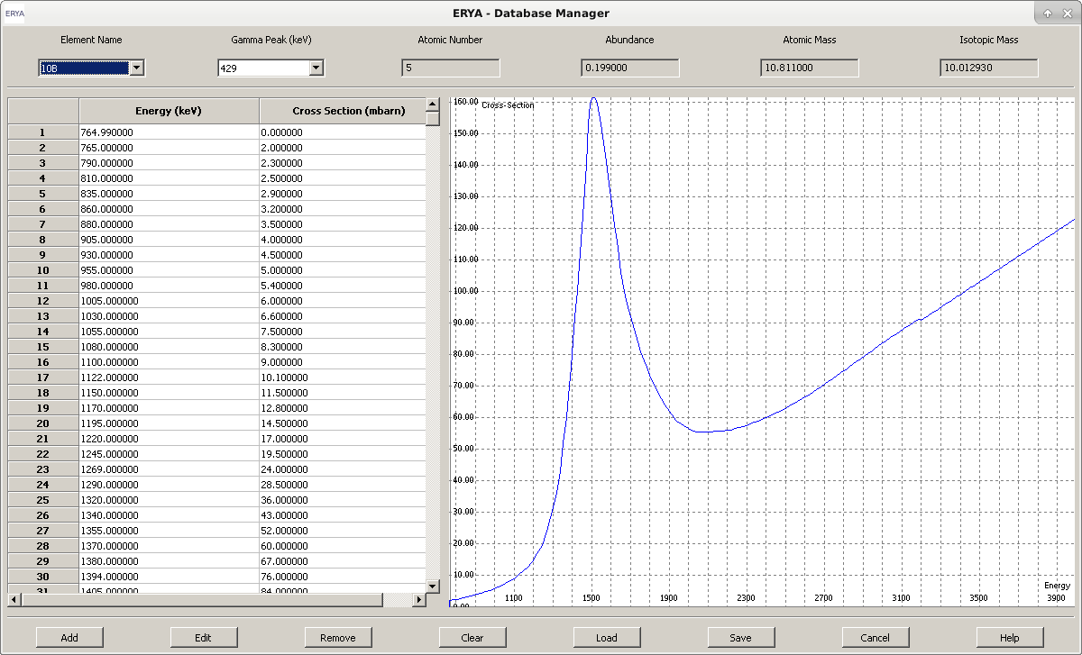

Using this tool, it is possible to handle the contents of one database at time (normally the default loading database when ERYA starts).

►By clicking on “Element Name” pull-down box, the selected element/isotope will refresh the “Gamma Peak” pull-down box, and then the user can select the available gamma emission peak form the same element.

For each Element/Gamma pair, a read-only Energy/Cross-Section table and graphical plot will be drawn. Up to four element physical proprieties will also be displayed.

The graphic plot can be zoomed or fitted to the screen, using the mouse. Additional commands are available on a right-click menu.

It will open a new dialog, and now the Element contents can be changed:

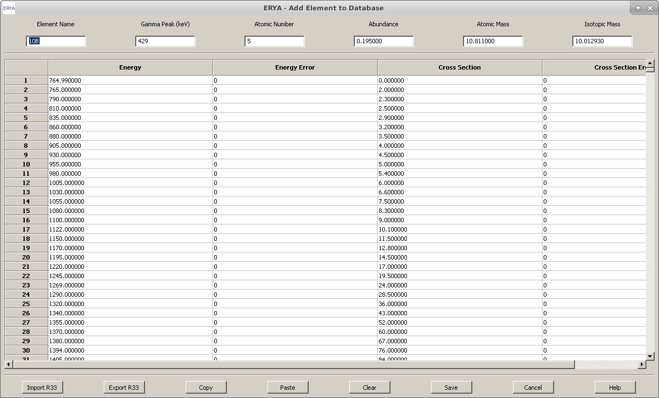

**Note:** The same widget are displayed when the user click on “Add”, but it will open a blanked dialog.

**Other Database Manager Options**

The other Database Manager available controls is the option that can delete the entire Database from memory (“Clear”), or load(“Load”) from and save(“Save”) to a file which should contains the source database related to the Element Database.

Notice that only overwriting the default database defined by the configuration file will be automatically reloaded when ERYA-Profiling starts.

**Editing the Elements Database**

A common operation on database management is the possibility to add or edit elements.

►To edit an element content, select the desired element and gamma peak from the *Database Manager* dialog panel, and click on “Edit”button, that will open a new dialog:



**Note:** The same widget are displayed when the user click on “Add”, but it will open a blanked dialog. Further explanation about elements editing will be detailed later.

►To delete an element, select the element and gamma peak to be remove, at click “Remove”.

ERYA will ask if you want to delete the selected element and gamma. Notice that the change are only permanent when the edited database are stored on disc.

►Select “Load” to load a database from file. The current database on memory will be replaced.

►To store a database on memory to disc, select “Save”. When overwrite the default loading database, the changes are permanent.

►To discard any editions made on the current database, hit “Cancel” button.

**►** Further information are available on on-line help dialog (“Help”).

**Adding/Editing new Elements**

The user can create new elements or editing new ones using the adequate controls on *Database Manager*, that will open a new dialog dedicated to the edition of all necessary parameters.

► Any element should have a unique name and gamma peak emission value. There’s no harm to add suffixes to the Element’s name, as long do not use unsupported characters. (See warning below.)

Every element register should had an Atomic Number, their Abundance (ranging from 0 to 1), and should place their Atomic and Isotopic Mass.

► The element’s cross-section spreadsheet can me manually typed, filling the four columns for the experimental cross-section and energies, and their experimental errors. The energy should be placed in keV units, and the cross-section with milibarns.

►Normally, the cross-section are experimental values stored on several file sources, and it is very rare to manually type on the built-in spreadsheet editor. (It is fine for about half a dozen of lines, but impractical for hundreds of lines.)

►To avoid manually input of cross-section contents, use “Import” button to enable direct file parsing of some file formats.

ERYA allows import and export of R33 (as those in IBANDL), ASCII and Excel’s xlsx files, where the latter require additional options to make a successful import, due to the requirement to convert units.

**Warning:** ERYA will check all physical parameters values written on top window, when the user export or save the new element register to the database.

All of them are pure numerical values, except the Element Name that had own strict rules.

If an Element Name contains spaces or any character that was not a number or a Latin letter, although an underscore “_” are accepted, ERYA will warn the user to fix the error.

**How to Import from External Files:**

**To import cross-section data from external files, select “Import”, then select one of those models:**

► **R33 Import:**

Select an **r33** format file, for example an IBANDL file, and ERYA will parse automatically without additional information.

Notice that if the file contains ambiguous data, or incompatible units, it will deliver an error message, aborting the whole process.

► **ASCII files import:**

Usually are text files that contains two columns of numeric data, and additional non-numeric lines of text.

When ERYA tries to parse such ASCII files, it will open an additional dialog asking the original cross-section units (milibarn or barn), or if the cross-section is differential or total. If ERYA fails to parse ASCII files due to the presence of non-numeric data, repeat the import procedure while select an additional option on the same import dialog to ignore any lines that are non-numeric data.

Once the parsing of the source file is completed, only numerical data related to the cross-section are placed on the built-in spreadsheet.

**►Excel files import:**

Import cross-section data from Excel files (as long it is saved on Excel 2007 and beyond versions with xlsx extension) is also possible, while opens an additional dialog to ask about the original cross-section units in the same manner on ASCII case, and the import profile with three different cases:

- First case – leaves ERYA to select automatically the import format from the original data. This is the recommended case, unless ERYA fails to decode the original Excel file structure.

- Second case – force ERYA to use the two columns import format, where the energy is placed in the first column, and the cross-section in the second column.

- Third case – force ERYA to use the four columns version, where the energy is place in the first column, and the cross-section in the third column. The second and fourth columns are reserved for the energy and cross section measurement uncertainties.

►To avoid import errors from Excel files, apply this rules:

- Store every relevant information on the first spreadsheet page, and group all relevant data on a single compact matrix block. It is not necessary to place everything from the first cell.

- Any rows with non-numerical data, or anything beyond the fourth relevant column are ignored.

**How to Export to External Files:**

To export the cross-section data from the current Element data, select “Export”, and select one of those three models:

► **R33 Export:**

ERYA can store the cross-section and some elemental physics parameters (including the name and gamma chosen on the *Element Editor*) on r33 (IBANDL) file format. The cross-section is given as total in milibarn units.

The comments fields contains ERYA software version, and the six original element references. If re-imported the r33 file again, such fields will be ignored.

Notice that ERYA will assume the reaction not change the nuclear species, requiring manual editing of the exported IBANDL file to fix some inaccuracies.

► **ASCII files export:**

ERYA will export only the cross-section data to a text file with two column of numeric data, without any additional information. The total cross-section are converted to barn units automatically and energy to keV.

**►Excel files export:**

ERYA will store only the cross-section as a single sheet numeric spreadsheet of data. The first row contains the original row labels of the ERYA’s cross-section editor. When selected this format, the program will ask to choose between a two or four-column file export, but it will always stored on total cross-section in milibarn units.

**A Simple Import Example:**

To explain the basic work-flow of create or editing Database’s Elements, we will show how to create a new element using an IBANDL file, and make a backup to a file, if you need to do so.

**1.** Go to IBANDL website at: [https://www-nds.iaea.org/exfor/ibandl.htm](https://www-nds.iaea.org/exfor/ibandl.html)

**2.** Select an nucleon, which can be any of the list, but choose a proton projectile (ERYA only support proton projectiles, or it will get an unrealistic physical modulation). It is highly recommendable to filter data types by PIGE only, and select the ones with “mb” or “tot” units format.

In this example save two or three samples with the highest number of cross-section points, where the target are the magnesium-26 isotope.

**3.** Save the relevant cross-section files as r33 files. (Click the “Save” button from the web-page.)

**4.** Start ERYA, then open the *Database Manager*, and finally, click “Add”.

The Element Editor widget, which should be blank, opens.

**5.** Select the relevant r33 files, from the “Import R33” button, and click “OK”.

Notice that ERYA will only display r33 files, if you select “IBANDL” files from the standard dialog window.

The program may ask to delete the main physical parameters located below the top window, and choose “Yes”, anyways.

It is normal that some of six Elements Parameters are automatically filled.

►On this example, the widget fills the following data, as display here:

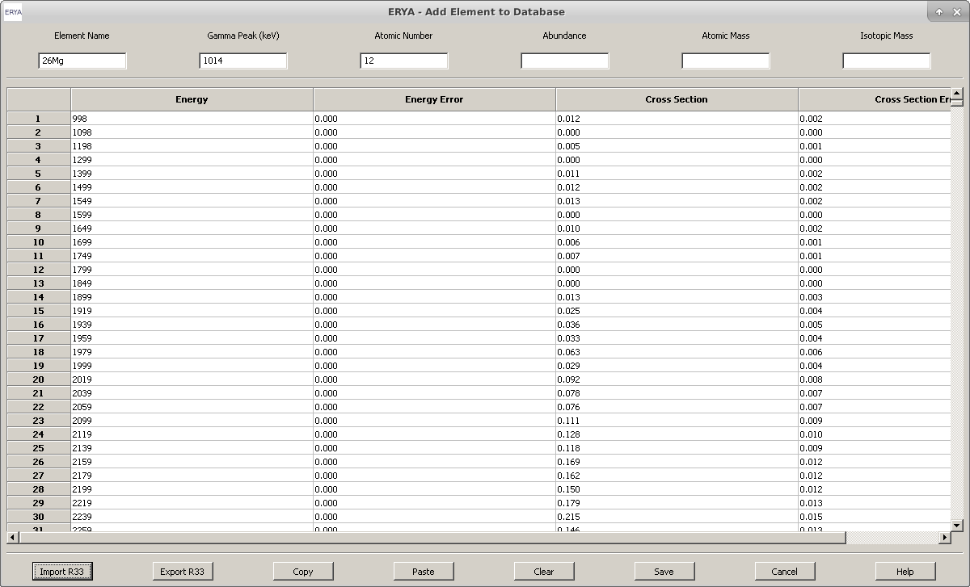

**6.** Using an isotope table, or an online reference material, fill the remaining gaps, like Abundance or the Isotopic Mass.

**7.** Click “Save”, and the new Database entry will be sorted and added.

The new element information will be displayed on Database Manager.

**Warning:** If ERYA detects another Database register with the same Name and Gamma Peak, it will asks to accept or abort. In case of accept, it will add a number suffix after an underscore (<x>_0, <x>_1, … ).

**8.** Repeat the steps 4 to 7 to add another entries.

**9.** Once return to the main Database Manager, click on “Save”, and select the start-up Database file, if you want to make permanent changes, or choose another name, if you want to keep the custom database separated.

**10.** The new elements are now available to use.

Useful Utilities

**LabView ERYA Import Wizard**

**Warning:** This section are only intended for the users that once used the old ERYA program built with LabView Runtime, and need to import the old databases to ERYA Profiling. Read carefully this guide before attempt any conversion.

This wizard will convert the main binary databases from the LabView ERYA program, plus some text files, to the native database formats handled by ERYA-Profiling.

While the Database Manager and the Stopping Power widgets can load directly the binary databases of the old program, and save directly to the new formats, it is highly recommendable to use the following wizard tool available on Tools > Import ERYA LabView.

The converted databases can be used safely on ERYA-Profiling, and also on ERYA-Bulk.

**1.** Before starting the wizard, verify if you have the following five files:

- The original LabView binary Ziegler’s Parameters file;

- The original LabView binary Elements Database file;

- A plain text file that should contains two columns of numerical data, for the Detector’s Efficiency.

- A plain text file for the Atomic Density (single column) for all elements of the periodic table.

- A plain text file for the Bloch Constants, preferentially for the all elements of the periodic table, with a single column.

**Tip:** Make a backup copy to ASCII or Excel of the Detector and Ziegler’s parameters currently active, using the ERYA database management tools described on this manual.

Finally, create the necessary text files using any text editor, and place along the binary files.

**2.** Once started the wizard, and pass the introduction page, the program will ask to select a compatible file from the following components, briefly explained by each wizard’s page:

- Element Database;

- Ziegler Parameters;

- Detector Efficiency;

- Element Atomic densities;

- Bloch’s Parameters;

**3.** Once inserted all source files, the wizard will displays three additional pages that will asks to give a name for each new database files with the native format handled by ERYA:

- Elements Database;

- Detector Efficiency;

- Stopping Power;

**4.** Once reached the final wizard’s page, click “Finish” to start the real conversion job. The whole process may take some seconds to finish, but will display an information dialog once completed the task.

**5.**  You should use the Database Management tools to handle the new files. Read the adequate manual chapters about how to edit the files, and fill any additional data.

Normally, it may need to add a custom Detector Efficiency function, and save with the updated information. The user can copy an original function, and paste on the same place after load the new detector file.

To merge the SRIM tables on the new Stopping-Power file, read the *Batch SRIM Import Wizard* section to ease the whole process.

**Using the ERYA Calculator**

This widget is intended to serve as a debug tool for some advanced options that use the ERYA macro language, and it is available from “Tools” > “Calculator”

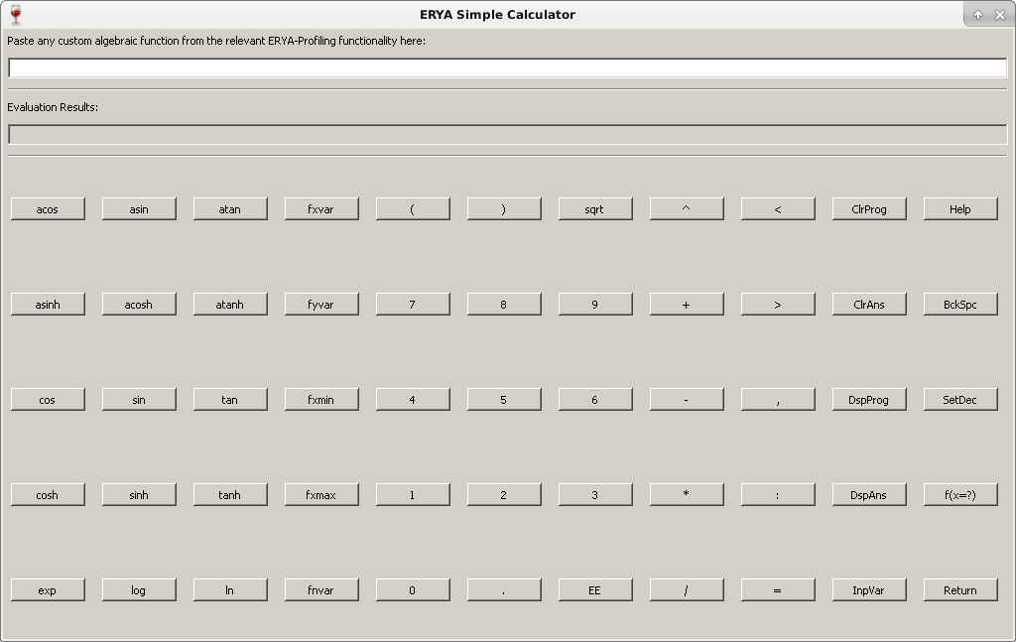The widget can also be used as a scientific calculator, if the user wanted to do so.

To use this tool, it’s possible to copy any ERYA macro expression stored on a compatible section, and past on the input box (the top one). Hitting “Return”, will display the results on the output box (the bottom one), or any error found during the macro execution.

The calculator will work correctly on *calculator mode*, if the input expression are a pure algebraic expression, without any commands related to functions (as seen on Detector or Stopping-Power chapters.). The calculator will display the numerical result once completed the macro evaluation, once the user press “Return”.

Otherwise the calculator can switch to *program mode*, when a proper function (Had the *fxvar, fyvar* parameters on input box) are properly defined. Since the calculator now expects an input, click “f(x=?)” button and fill the numerical value, on the opened dialog.

If the macro are correctly well-defined, it should return the function result on the output box. Notice that to run a function macro, do not use the “Return” button.

A more detailed documentation are available on program’s on-line help.

**SRIM Import Wizard**

In order to ease the import of several SRIM Stopping Power tables created by the SRIM® software itself, an auxiliary wizard was created to batch the conversion of several tables at once.

The user need to select pure element stopping powers, where ERYA will only support the incident proton (hydrogen) beams. Once created all necessary files from the SRIM® software, start the *SRIM Import Wizard* itself, and follow the instructions:

**1.** Once passed the introduction page, the first relevant page will display a file manager and associated controls to load several source SRIM® files at once. To start, click “Load”.

► To select more than one file, hold down Ctrl key, and select multiple files with the mouse.

All selected files will appear on the file manager list. It is also possible to delete one of the list, requiring to select one and click “Remove”. The “Clear” button will clear the file manager list.

**2.** On next wizard page will give the possibility to retrieve an existent Stopping-Power’s database file, or to use the current active Stopping-Power database on ERYA memory, leaving also the possibility to not copy any external data at all.

Notice that only the Ziegler’s Parameters are actually imported by this wizard.

**3.** Finally, the wizard will asks to name the new Stopping-Power database file.

**4.** Once make all main three steps on wizard, the batch conversion should be done in a couple of seconds. When completed the conversion, the new file once opened by the Stopping-Power Editor should display the contents on the “SRIM” tab by the atomic number’s order.

**Note:** If the batch list contains repeated files with the same atomic number, only the last one are stored, while overwrites the previous ones.

**Attention:** Take notice that incorrect SRIM® files on the batch are discarded by the wizard without warning the user.

How to make a Profiling Analysis

The main purpose of ERYA - Profiling is to make a yield spectrum in function of energy, and the depth of the sample. Future improvements are under current discussion, so this chapter will detail the implemented features.

**Main Interface Features**

If ERYA-Profiling are correctly configured, then all default databases will be loaded automatically on start-up, displaying a full window screen like this example below:



The program uses a tabbed interface, where each tab had own functions and tools.

Database management are handled by the menu interface, as already described on previous chapters of this manual.

The bottom screen contains some buttons dedicated to the simulation and some special configuration settings.

At the bottom of main window, exists a status bar for some internal information, as will be briefly useful during the numerical evaluations.

By clicking “Open User Guide”, it will display a resumed how-to tutorial of this current printed guide, with links for additional topics. Also each tab had own on-line help button for additional information.

**First Step: Define the Number of Elements**

**1.** Select the “Elements Editor” tab, and then select the number of Elements needed for all sample.

**2.** Once selected the adequate number of Elements, as notice that adding or removing won’t reset the remaining contents on the dynamic table, in order to change the Element Name, then:

- Once select an element from the Elements switch widget, it will reload the Gamma Peaks pull-downs that corresponds to the selected element. It will also update the basic information for the selected element from the Database.

**3.** Only select the relevant Gamma Peak of the Element, after finishes all previous element selection.

**4.** It is possible to change the four physical elements parameters, overridden the default values giving by the database, when start the numerical simulation.

- This feature can be useful on samples with abnormal isotopic abundances, that also avoid unneeded Databases editions.

**5.** The current elements and gamma peaks selection will update the tables of other tabs, as it will detail later.

**Extra:** It’s possible to store the custom sample composition on a template file. It can be a normal Excel file, or a native XML based file with extension **epcs**. (ERYA Profiling Compound Sample)

- This is useful to load template sample files without manually typing all over again.

**Second Step: Define the Number of Layers, and Detail their Composition**

**1.** Select the “Layer Editor” tab, and once confirmed the selected elements name and gamma on the new table are correctly assigned, select the number of layers on this step.

**2.** Define the depth of each layer on 1015 at/cm2 units, on the first column, and then the relative stoichiometry of each element. The program will make an internal renormalization during the main numerical simulation, then there’s no need to comply a manual input as long their sum should be equal to one, since ERYA will fix without any additional user intervention.

**Extra:** It’s possible to store the layer contents on an Excel file, or a native XML file with **epls** (ERYA Profiling Layer Sample) extension. This may avoid manual typing of every sample when ERYA starts, when only requires to change some values between a series of simulation, once loaded a layer template from memory.

Notice that loading templates on the “Layer Editor” will reload the “Element Editor” to the default database values, at this current program implementation.

- To avoid a custom data reset from the first tab, the user can write the numerical data directly on the layer built-in spreadsheet editor, or load a text file with the numerical data from the sample.

**Extra Step: Using an Excel File or a ASCII file to Import a Template**

Previous ERYA versions (including the LabView version) could load a text file with a sample composition and import directly, avoiding a manual typing.

On ERYA-Profiling, this feature was greatly improved, where the major improvement was the Excel file import of a template, as it will detail here.

**1. Excel File Option:**

The Excel option had an additional advantage of the text import, since it is possible to use the first row as labels, and define directly the Elements and Gammas on their respective numerical columns.

Select any initial cell of an empty Excel file on the first worksheet, while maintain a compact matrix of data to avoid importation errors.

The first column of the first row will be the depth column label, that can be any word, and then place the elements on the next right columns of the same row, their names and gammas.

The most usual label format is the form <Symbol> <Gamma>, separated by a space, like “*19F 197”* on a cell to represent the 197 keV gamma of the isotope 19F from the Database. Other variations are permitted, and are detailed on the on-line help reference.

Then write the correct values for the depth and stoichiometry of each element aligned to the correct column label, like the built-in editor form ERYA-Profiling.

Once written all data, save the contents in an Excel Xlsx File Format (version 2007 or greater).

On ERYA, use “Load Table” and select the new created Excel File. It should extract the data and fill the “Element” and “Layer” editor automatically.

It is necessary to take care to not select an non-existent element or gamma, or the program will warn about a non-existent isotope from the current database, aborting the import.

To fix that, the user should open the Excel file again and make the necessary corrections.

It’s possible to export a pure numerical table on an Excel file, but require the user to define manually the number and names of all elements previously, or load an additional Excel file for the “Elements Editor” tab forehand.

**2. ASCII File Option:**

To load a text file with the sample composition, define all number of elements and gammas forehand, then load the file.

The sample file should have only numerical data, where each column element are separated by tabs.

A mistake to previous elements declaration when load the file will give a failed importation error.

**Third Step: Define the Detector Parameters, and Resonances**

**1.** Select the “Detector and Resonances” tab once completed the previously steps.

**2.** The user can now fill the main Detector physical parameters, and the number of energy samples, by defining a Energy Step along a Minimum and Maximum Energy sequence.

**3.** Optionally is possible to define a Lorentzian Resonance, or even a custom Function Resonance using the ERYA macro language.

**3.1**  The Lorentzian resonance accept several values on Resonance peak, width and energy, as long that had the same number of elements separated by commas (,), and placed on the same order.

- The optional Maximum and Minimum Energy for the Lorentzian, even they had multiple peaks, are always a single valued input.

**3.2** A custom resonance function should be declared with four keywords, like the following example:

**fxvar = x, fyvar = y, fxmin = a, fxmax = b: a= 1100, b= a + 10, h = 100: y = h * exp(-1*(x-a)^2)**

- Since ERYA needs to know the absolute values for the minimum (fxmin), and maximum (fxmax) values for energy for the resonance function, along the usual fxvar and fyvar keywords for the function variables.

**4.** Select the correct resonance mode using the bottom menu of this tab, where the default setting is to ignore any custom resonance at all, or choose the Lorentzian or Custom Resonance function.

**Extra:** It’s possible to save the current Detector and Resonance values on a XML file with **eprs** (ERYA Profiling Resonance Settings) extension, that don’t affect other tabs data.

**Additional Tip.**

To save all contents of “Element Editor”, “Layers Editor” and “Detector and Resonance” tabs, along some additional values at once, use “File” > “Save” and save on a XML file with extension **epgs**. (ERYA Profiling Global Sample). This also saves any custom change on Elements physical parameters.

When load a **epgs** file, with “File” > “Load”, it will load all three tabs contents automatically, including all custom Elements physicial parameters.

It’s up to the user prefer a single sample file, or three separated files to archive all sample data and user inputs.

**Last Step: Make the Simulation**

**1.** Once everything is done, according to the previous steps, hit the “Run Simulation” button.

- if no error are reported, the simulation will begin while displaying the percentage on the bottom status bar, and also on a progress bar window.

- Since a complex sample may take a long time to complete (the user can change the precision setting on the “Advanced” button, as it will explained latter.), the progress bar will inform the user about the real task in progress.

**2.** Once completed, the results are displayed on a graphic plot on “Output Results”, a numerical table of the same plot on “Table Output”, and a log of several intermediate values on the “Log Details” tab.

- Normally, the “Log” table will be empty, as the logging are disabled by default.

- To change some precision parameters, and other features, read the next sections of this manual.

**Changing Accuracy Parameters (Optional)**

If required, it is possible to change the accuracy parameters by clicking the “Advanced Options” button on the bottom main page controls, which opens a simple widget:

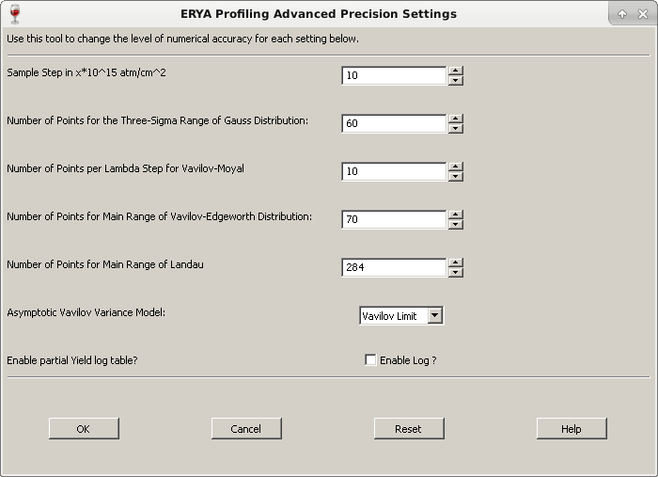

On most realistic scenarios, the user only change the Sample Step (Using 1015 at/cm2 units), where their range are from 1 to 1000 (default is 10). A smaller number on Sample Step may be needed with samples that contains sharp resonances, but it will increase the the simulation time.

Smooth cross-sections can be computed more fast, by choosing a greater Sample Step without losing much accuracy.

The next four parameters are related to the number of points of the intervals of integration related to the distributions, as explained on the brief theoretical chapter. The on-line reference contains some more detailed information.

The pull-down option is to select between the Vavilov or Bohr variance formulas for the stragging distribution, applicable when all distributions goes to the Gaussian Limit. An additional pure Gaussian for straggling is also available.

On bulk samples, the results of both three options are approximately the same, but it will computationally much faster if the “Gaussian Only” option are selected, in some cases between ten to a hundred times faster than the Vavilov distribution.

The last option is a check-box that enables or disables the partial yields logging, which are filled on the “Log” tab. Disabling it can save time and memory, specially when an huge sample ends the simulation, and delays the outputs due to the processing of hundreds of thousands lines , or even a few millions of lines of spreadsheet data!

Normally the Log Table are only useful for small samples, and when needed to get the distributions parameters for each step layer to make additional analysis.

**Import Experimental Data**

Once the results are displayed on “Output Results”, mainly the graphical plot, it is possible to add additional plots of experimental data.

► To import experimental data to ERYA, will requires an Excel file with two columns of numerical data (any rows with non-numerical data will be ignored), or an ASCII filled with two tabbed columns of numerical data.

Then click on “Import Experimental Data”, and select the correct file, that once done correctly, will make a new plot with the experimental values, along the interpolated data on the “Table Output”.

To add another experimental data, simply repeat the same procedure again.

► ERYA data memory are only deleted if the user click on “Clear All” button.

**Attention:** Notice that the experimental data, once plotted on the cited tab page, will also appears on the rightmost columns of the “Table Output” tab, but interpolated to match the energy spectrum created by the previous numerical simulation.

**Saving Results**

ERYA Profiling provides three possible output files, as described below:

At first glance, it’s possible to save the current graphic plot as an image image, using the “Save As Image” button from the “Output” tab page, and then select one of the four images types supported by this program.

If you zoom the image or crop the plot, when save the changed plot to the file, the changed plot will be stored as an image file as expected to be.

Using the “Table Output” and “Log Details” tabs pages buttons, it is possible to save the tables either by an ASCII text file, or an Excel file. Either way, the Excel format is more friendly for further data processing.

Since the log file of huge samples can creates tables with several thousands of lines, and ERYA-Profiling can take some minutes to save an Excel file with some hundred thousand rows, in this case, it is preferable to use the ASCII file.

The ERYA’s own Excel library can crash with such gigantic volume of data, since it was not designed to create enormous files, and also ignore the Excel file limitations.

**Some Useful Tips**

**-** Use the built-in tools described on this tutorial, to define the sample composition, and the detector parameters. It’s much better than export from text or Excel files.

- Save all samples as **epgs** files form the “File” > “Save As”, in order to create a collection of master samples. This is useful to run multiple simulations when only a few values are changed, since once the file are loaded by the program, avoiding to fill everything manually.

- If the elements belonging to a sample have a smooth cross-section, increase the Sample Step, on the “Advanced Options” button. This will reduce the computation time.

- If the simulated sample are a bulk one, without sharp resonances or not needed much accuracy, select the “Gaussian Only” straggling mode. It will perform the simulation much faster than the Vavilov distribution mode.

- On samples with elements that have sharp resonances, reduce the Sample Step, in order to avoid loss of accuracy.

**A Profiling Example**

A good (and long time consuming) example is to simulate the sharp 105 eV resonance of Aluminum-27 at 992 keV.

►To reduce the computation time, start some ERYA-Profiling instances, where each one run a partial energy spectrum. Then run both of them at the same time, since modern computers had several processors on the same chip, making possible to run some simulations in parallel.

**1.** Define a sample with pure 27Al, with 3*1020 at/cm2 (300000 units) of depth, enough to absorb the proton beam at energies around 1 MeV.

**2.** Define the Detector Setup (0.1 keV Detector Resolution, with 0K for the thermal dispersion, and 1 µC of charge) and a Lorentzian Ressonance (1000 mbarn maximum peak, 0.105 keV width at 992 keV).

**3.** With a sharp resonance, reduce the sample step (Advanced) to 1015 at/cm2 or 5*1015at/cm2 (1 to 5 units), but maintain a Vavilov distribution for straggling.

**4.** Save the actual settings to a profile file (File > Save As), that will store all inputs.

**5.** Load several ERYA-Profiling (the same number of processors that your computer had) at once, and at each one load the same profile file. For each ERYA-Profiling running, define the initial and final energy of each partial segment, and a step of 0.1 keV.

►To run a simulation from 990 to 1006 keV, where each partial simulation spans over 2 keV, it would require 8 simultaneous simulations. Reducing to 1 keV, requires 16. If the the number of total simulations exceeds the number of processors, don’t run them at once, instead start a first batch, and wait until finishes to start another ones.

**6.** Once each simulation finishes, save the yields to a file (An Excel file will be fine).

►Once all batched simulations finishes, merge all partial results into a single file.

**Note:** While it would be possible to run the entire profiling simulation in a single instance (for 990 to 1006 keV) the computational time will be huge (several hours).

Currently, ERYA-Profiling don’t provide any kind of real multi-threading, and therefore only a full processor will be constantly used by this software. There’s some internal discussions about the possibility to create a multi-threaded algorithm for ERYA-Profiling, but until this time none of this was implemented.

Although the results may vary for each simulation setup (different detector’s efficiency, for example), the simulated sharp resonance of 27Al will be similar to the following picture:

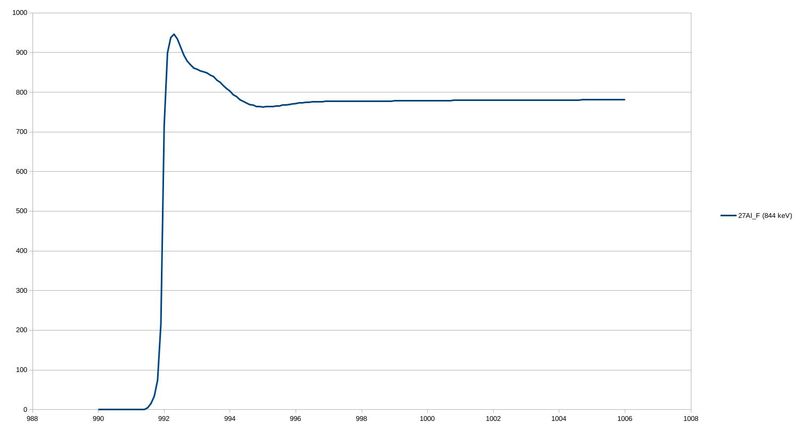 The yield profiling displays a fast yield increase until the resonance peak, followed by a fast decay as the energy increases, as expected for a sharp resonance.

More accurate models, that uses stochastic simulation, deliver a more realistic simulation for sharp resonances, giving a better treatment of the yield decay post the resonance.

Bibliography

**Note:** The research materials are the same of the LabView ERYA program.

- R. Mateus, A.P. Jesus, J.P. Ribeiro, Nucl. Instr. and Meth. B 229 (2005) 302.

- PhD thesis: "Análise de elementos leves por reacções nucleares com produção de radiação gama", Maria Micaela Leal da Fonseca, Faculdade de Ciências e Tecnologia da Universidade Nova de Lisboa (2010).

- PhD thesis: "Recolha Automática de aerossóis e a sua análise por técnicas analíticas nucleares", Rodrigo Clemente Velez Mateus, Faculdade de Ciências da Universidade de Lisboa (2003).

-PhD thesis: “Programa para análise em profundidade por técnicas nucleares”, Luís de Souto Martins, Faculdade de Ciências da Universidade de Lisboa (2013).

- J. F. Ziegler, J. P. Biersack, U. Littmark, in "The Stopping and Ranges of ions in Solids", Vol. 1, Pergamon Press, New York, 1985.

- SRIM website: <http://www.srim.org/>; J.F. Ziegler, Nucl. Instr. and Meth. B219-220 (2004) 1027.

- IBANDL website: <http://www-nds.iaea.org/ibandl/>

**Additional reference:**

- “Numerical Analysis”, Richard L. Burden, J. Douglas Faires, Brooks/Cole Publisher Company.

- wxWidgets website: <http://www.wxwidgets.org/>

- wxWidgets 3.0 reference manual: <http://docs.wxwidgets.org/3.0/>

- wxWidgets reference book: “Cross-Platform GUI Programming with wxWidgets”, Julian Smart and Kevin Hock with Stefan Csomor, Prentice Hall (2005).

- wxMathPlot add-on: <http://wxmathplot.sourceforge.net/>

- LabView DataLog reverse-engeenering file structure reference: <https://sccn.ucsd.edu/svn/software/tags/EEGLAB7_0_2_6beta/external/fieldtrip-20090727/private/read_labview_dtlg.m>

- Excel 2007 file documentation: <https://www.codeproject.com/Articles/208075/How-to-read-and-write-xlsx-Excel-file-Part-I> ; <https://www.codeproject.com/Articles/210014/How-to-read-and-write-xlsx-Excel-file-Part-II>